# **Lab 1: Learning Basic Linux Commands**

**OS Used**: Debian 5.18.5-1kali6

## **1.1. Command Name:** ls

**Syntax**: ls [OPTION]... [FILE]...

**Usage**: Lists files and directories within the file system and shows detailed information about them.

### **Commands Executed:**

- $ ls — Lists all unhidden files and directories in the current directory.

- $ ls -l — Lists files in long listing format, including file type, permissions, owner, and more.

- $ ls -a — Displays all files, including hidden files (starting with a dot).

**Output**:

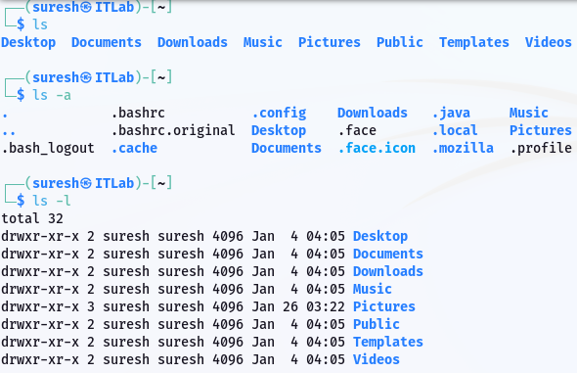

## **1.2. Command Name:** cd

**Syntax**: cd [directory]

**Usage**: Changes the current working directory to the specified directory.

### **Commands Executed:**

- $ cd /home — Navigates to the /home directory.

- $ cd .. — Moves up one level in the directory hierarchy.

- $ cd ~ — Moves to the user’s home directory.

**Output**:

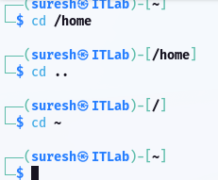

## **1.3. Command Name:** grep

**Syntax**: grep [OPTION]... PATTERNS [FILE]...  
**Usage**: Searches for a specific pattern within files or input and highlights matching lines.

### **Commands Executed:**

- $ grep "hello" file.txt — Searches for the word "hello" in file.txt.

- $ grep -i "hello" file.txt — Performs a case-insensitive search for "hello".

- $ grep -r "error" /var/log — Recursively searches for "error" in /var/log directory.

**Output**: 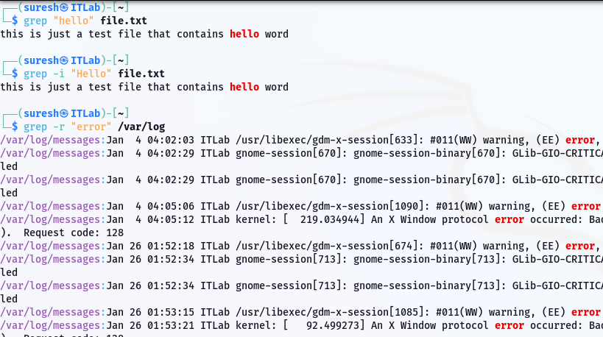

## **1.4. Command Name:** su/sudo

**Syntax**: su/sudo [options]

**Usage**: Allows a user to switch to another user or execute commands with elevated privileges.

### **Commands Executed:**

- $ sudo apt update — Updates package lists with administrative privileges.

- $ sudo su — Switches to the root user.

- $ sudo -i — Starts a root shell session.

**Output**: 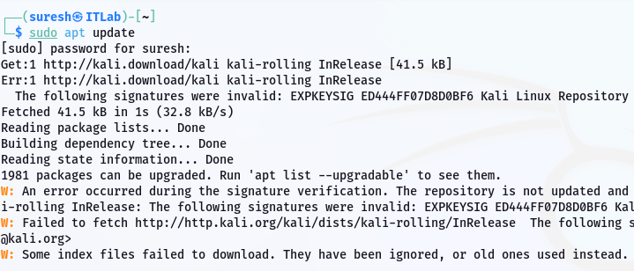

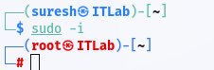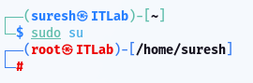

## **1.5. Command Name:** pwd

**Syntax**: pwd [options]…

**Usage**: Prints the current working directory.

### **Commands Executed:**

- $ pwd — Displays the full path of the current directory.

**Output**:

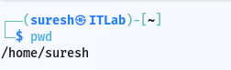

## **1.6. Command Name**: mv

**Syntax**: mv [OPTION]... SOURCE... DIRECTORY

**Usage**: Moves or renames files and directories.

### **Commands Executed:**

- $ mv file.txt new_file.txt — Renames file.txt to new_file.txt

- $ mv new_file.txt Desktop/file.txt — Moves new_file.txt to Desktop folder naming it file.txt.

**Output**:

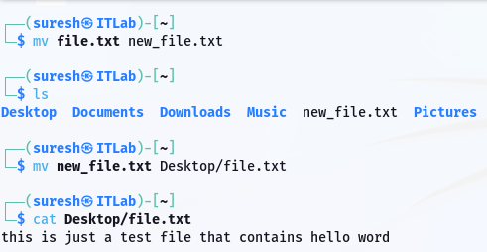

## **1.7. Command Name**: cp

**Syntax**: cp [OPTION]... SOURCE... DIRECTORY

**Usage**: Copies files and directories.

### **Commands Executed:**

- $ cp file.txt new_file.txt — Copies file.txt to new_file.txt.

- $ cp -r folder /backup/ — Recursively copies the folder to /backup.

**Output**:

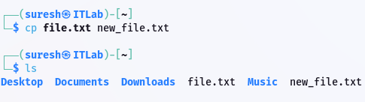

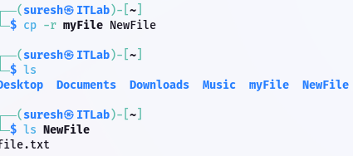

## **1.8. Command Name:** rm

**Syntax**: rm [OPTION]... [FILE]...

**Usage**: Deletes files or directories.

### **Commands Executed:**

- $ rm file.txt — Removes file.txt.

- $ rm -r myFile/ — Recursively deletes the folder.

- $ rm -i file.txt — Prompts for confirmation before deletion.

**Output**:

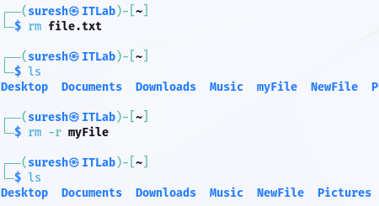

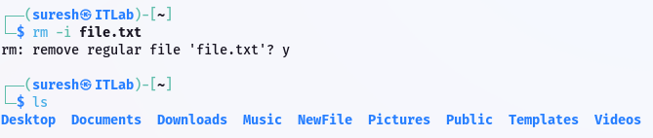

## **1.9. Command Name**: mkdir

**Syntax**: mkdir [OPTION]... DIRECTORY...

**Usage**: Creates a new directory.

### **Commands Executed:**

- $ mkdir myFile— Creates a directory named myFile.

- $ mkdir -p Parent/Child — Creates Parent and Child directories in one command.

**Output**:

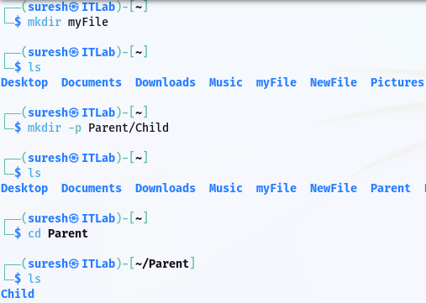

## **1.10. Command Name**: rmdir

**Syntax**: rmdir [OPTION]... DIRECTORY...

**Usage**: Removes empty directories.

### **Commands Executed:**

- $ rmdir Child — Removes the empty directory named Child.

- $ rmdir -p Parent/Child — Removes child and parent directories if they are empty.

**Output**:

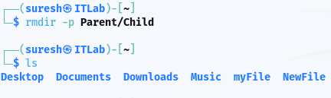

## **1.11. Command Name:** chmod

**Syntax**: chmod [OPTION]... [MODE]... FILE…

**Usage**: Changes the permissions of a file or directory. Numbers 4, 2, 1 are assigned for read, write, and execute. E.g.: 4+2+1 = 7, which allows all three: read, write, and execute.

### **Commands Executed:**

- $ chmod 755 script.sh — Assigns read, write, and execute permissions for the owner and read/execute for group and others.

- $ chmod +x script.sh — Adds execute permission to script.sh.

**Output**:

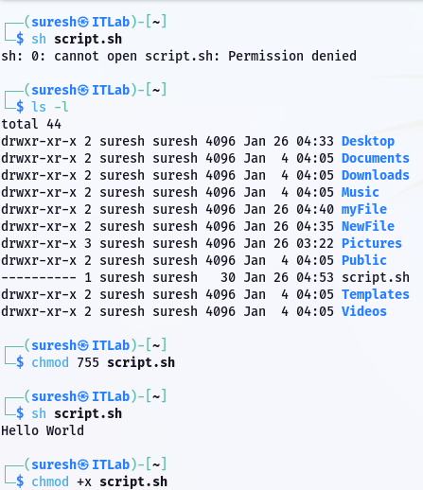

## **1.12. Command Name:** cat

**Syntax**: cat [OPTION]... [FILE]...

**Usage**: Concatenates and displays the content of files.

### **Commands Executed:**

- $ cat combined.txt — Displays the content of combined.txt.

- $ cat file1.txt file2.txt > combined.txt — Combines file1.txt and file2.txt into combined.txt.

**Output**:

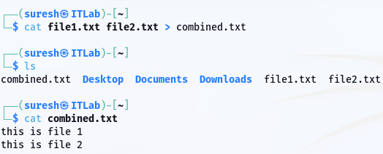

## **1.13. Command Name:** chown **Syntax**: chown [options] owner[:group] file...

**Usage**: Changes the ownership of a file or directory to a specific user or group.

**Commands Executed:**

* $ chown hari file.txt — Changes the ownership of file.txt to the user hari.
* $ chown suresh:suresh file.txt — Changes the ownership of the file.txt to user hari and group hari.

**Output:**

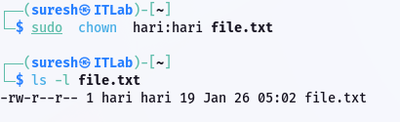

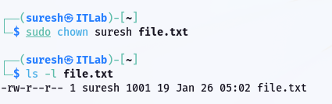

## **1.14. Command Name:** echo

**Syntax:** echo [options] [string...]

**Usage:** The echo command is used to display a line of text or variables to the terminal. It’s commonly used in scripts or to display messages in the terminal.

**Commands Executed:**

* $ echo "Hello, World!" — Displays the text "Hello, World!" in the terminal.
* $ echo $HOME — Displays the value of the HOME environment variable.

**Output:**

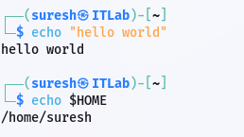

## **1.15. Command Name:** wc

**Syntax**: wc [OPTION]... [FILE]...

**Usage**: Counts words, lines, characters in files.

### **Commands Executed:**

- $ wc file.txt — Displays the number of lines, words, and characters in file.txt.

- $ wc -l file.txt — Counts only the lines in file.txt.

- $ wc -w file.txt — Counts only the words in file.txt.

- $ wc -c file.txt — Counts only the characters in file.txt.

**Output**:

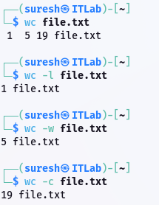

## **1.16. Command Name:** man

**Syntax**: man [options]… [Command]

**Usage**: Displays the manual page of a command.

### **Commands Executed:**

- $ man ls — Opens the manual page for the ls command.

**Output**:

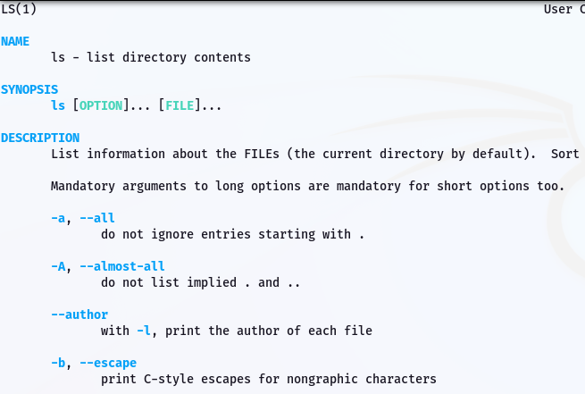

**1.17. Command Name:** history

**Syntax:** history [options]

**Usage:** The history command shows the list of previously executed commands in the terminal session. It allows users to recall and reuse commands from the history list.

**Commands Executed:**

$ history — Displays the list of previously executed commands.

$ history | grep "uname" — Searches the command history for occurrences of "uname".

**Output:**

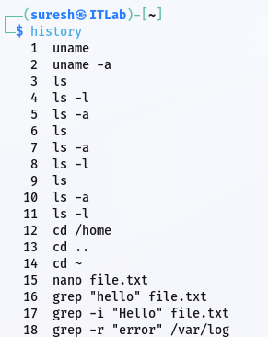

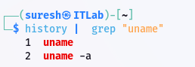

## **1.18. Command Name:** clear

**Syntax**: clear [options]

**Usage**: Clears the terminal screen.

### **Commands Executed:**

- $ clear — Clears all previous terminal output.

**Output**:

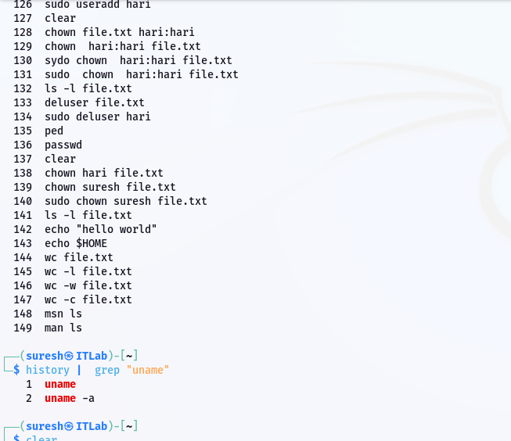

*Figure 1 Before executing the command*

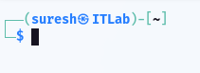

*Figure 2 After executing the command*

## **1.19. Command Name:** touch

**Syntax**: touch [OPTION]... FILE...

**Usage**: Creates an empty file or updates the timestamp of an existing file.

### **Commands Executed:**

- $ touch newfile.txt — Creates a new empty file named newfile.txt.

**Output**:

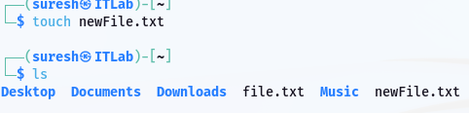

## **1.20. Command Name:** locate

**Syntax**: locate [OPTION]... PATTERN...

**Usage**: Finds files by name.

### **Commands Executed:**

- $ locate file.txt — Searches for the specified filename in indexed file paths.

**Output**:

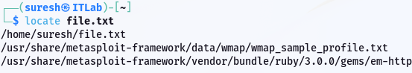

## **1.21. Command Name:** netstat

**Syntax**: netstat [options]

**Usage**: Displays network connections and statistics.

### **Commands Executed:**

- $ netstat -a — Shows all active connections.

**Output**: 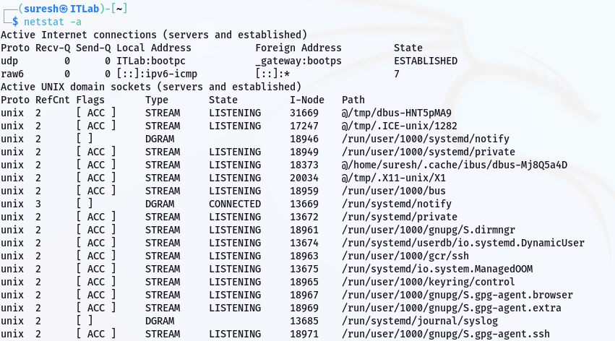

## **1.22. Command Name**: df

**Syntax**: df [OPTION]... [FILE]...

**Usage**: Displays available disk space.

### **Commands Executed:**

- $ df -h — Shows disk usage in a human-readable format.

**Output**:

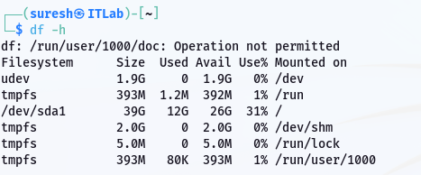

## **1.23. Command Name:** du

**Syntax**: du [OPTION]... [FILE]...

**Usage**: Displays the disk usage of files or directories.

### **Commands Executed:**

- $ du -sh Downloads — Displays the size of a Download folder in a human-readable format.

**Output**:



## **1.24. Command Name:** uname

**Syntax**: uname [option]…

**Usage**: Displays system information.

### **Commands Executed:**

- $ uname -a — Shows all system information including kernel, OS version, etc.

**Output**:



## **1.25. Command Name:** passwd

**Syntax**: passwd [options]

**Usage**: Changes the password of a user.

### **Commands Executed:**

- $ passwd — Prompts to change the current user’s password.

**Output**:

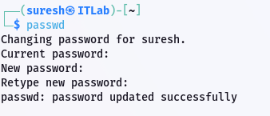

## **1.26. Command Name**: useradd

**Syntax**: useradd [options] [NAME]

**Usage**: Adds a new user to the system.

### **Commands Executed:**

- $ useradd hari — Creates a new user named hari.

**Output**:







## **1.27. Command Name:** userdel

**Syntax**: userdel [options] [Name]

**Usage**: Deletes a user from the system.

### **Commands Executed:**

- $ userdel hari — Removes the user named hari.

**Output**:



## **1.28. Command Name:** apt-get

**Syntax**: apt-get [options]

**Usage**: Manages software packages on Debian-based systems.

### **Commands Executed:**

- $ apt-get update — Updates package lists.

- $ apt-get upgrade — Upgrades installed packages.

- $ apt-get install cmatrix — Installs a specified package - cmatrix.

**Output**:

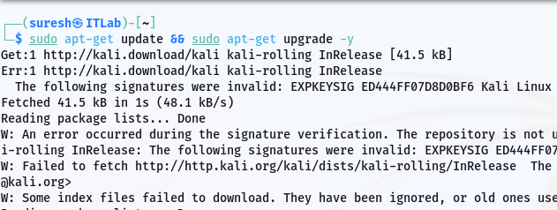

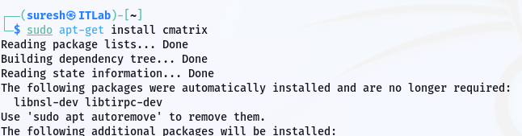

## **1.29. Command Name:** ping

**Syntax**: ping [options] <destination>

**Usage**: Checks network connectivity to a host.

### **Commands Executed:**

- $ ping google.com — Sends ICMP packets to test connectivity with google.com.

**Output**: 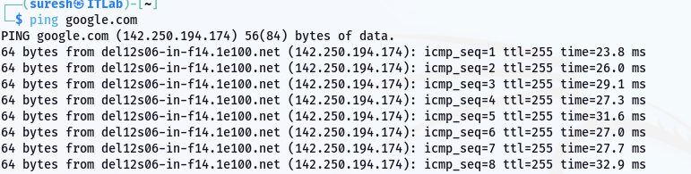

## **1.30. Command Name:** find

**Syntax**: find [directory] [options] [filename]

**Usage**: Searches for files or directories.

### **Commands Executed:**

- $ find /home -name 'file.txt' — Searches for file.txt in the /home directory.

**Output**:

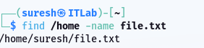

## **1.31. Command Name:** head

**Syntax**: head [options] [filename]

**Usage**: Displays the first few lines of a file.

### **Commands Executed:**

- $ head file.txt — Displays the first 10 lines of file.txt.

**Output**:

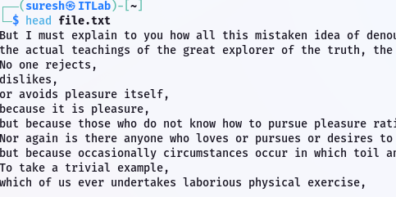

## **1.32. Command Name:** rename

**Syntax**: rename [pattern] [files]

**Usage**: Renames files in bulk.

### **Commands Executed:**

- $ rename 's/\.txt$/\.html/' *.txt – Renames all .txt files into .html file.

**Output**:

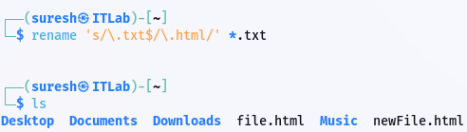

## **1.33. Command Name:** tail

**Syntax**: tail [options] [filename]

**Usage**: Displays the last few lines of a file.

### **Commands Executed:**

- $ tail file.txt — Shows the last 10 lines of file.txt.

**Output**:

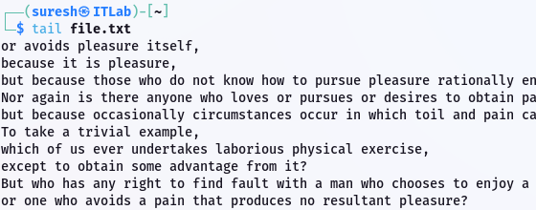

## **1.34. Command Name**: tac

**Syntax**: tac [options] [filename]

**Usage**: Displays file contents in reverse order. As ‘cat’ command shows file contents in correct order, this command is reverse of CAT : TAC.

### **Commands Executed:**

- $ tac file.txt — Displays the content of file.txt in reverse line order.

**Output**:

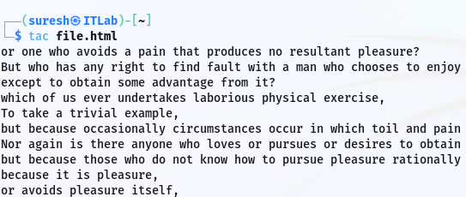

## **1.35. Command Name:** comm

**Syntax**: comm [options] [files]

**Usage**: Compares two sorted files line by line.

### **Commands Executed:**

- $ comm file1.txt file2.txt — Compares file1.txt and file2.txt.

**Output:**

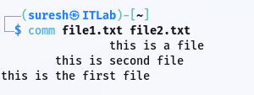

## **1.36. Command Name:** cut

**Syntax**: cut [options] [file]

**Usage**: Removes sections of lines from files.

### **Commands Executed:**

- $ cut -d',' –f2 file.csv — Extracts the second field of a CSV file.

**Output**:

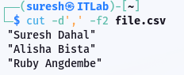

## **1.37. Command Name:** sort

**Syntax**: sort [OPTION]... [FILE]...

**Usage**: Sorts the contents of a file.

### **Commands Executed:**

- $ sort file.txt — Sorts the lines in file.txt alphabetically.

**Output**:

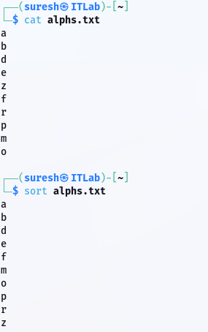

## **1.38. Command Name:** date

**Syntax**: date [OPTION]... [+FORMAT]

**Usage**: Displays the current date and time.

### **Commands Executed:**

- $ date — Shows the current system date and time.

**Output**:

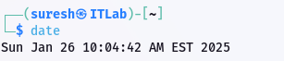

## **1.39. Command Name:** cal

**Syntax**: cal [options]

**Usage**: Displays a calendar.

### **Commands Executed:**

- $ cal — Displays the current month’s calendar.

**Output**:

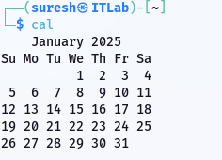

## **1.40. Command Name:** time

**Syntax**: man [OPTION...] [SECTION] PAGE...

**Usage**: Measures the execution time of a command.

### **Commands Executed:**

- $ time ls — Measures how long it takes to execute the ls command.

**Output**:

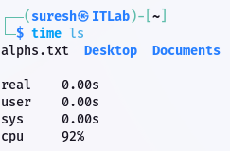

## **1.41. Command Name**: host

**Syntax**: host [OPTION] [URL]

**Usage**: Performs DNS lookups.

### **Commands Executed:**

- $ host google.com — Retrieves the IP address of google.com.

**Output**:

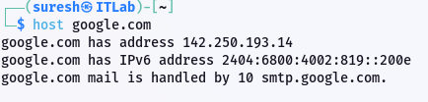

## **1.42. Command Name:** wget

**Syntax**: wget [OPTION]... [URL]...

**Usage**: Downloads files from the web.

### **Commands Executed:**

- $ wget https://sureshdahal.com.np/suresh_dahal_frontend_developer_codersuresh_resume.pdf — Downloads the specified file.

**Output**:

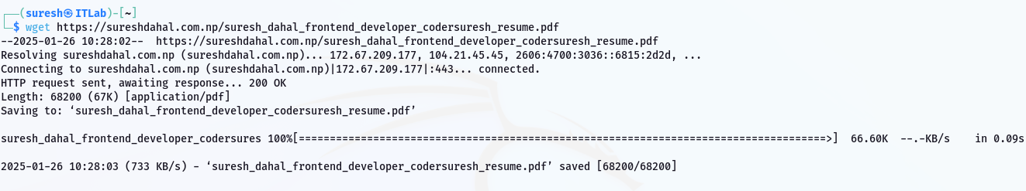

## **1.43. Command Name:** id

**Syntax**: id [OPTION]... [USER]...

**Usage**: Displays user ID and group ID information.

### **Commands Executed:**

- $ id — Displays ID information of the current user.

**Output**: 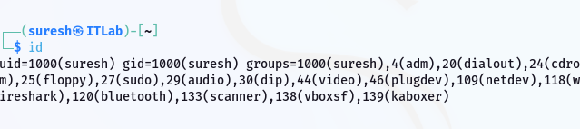

## **1.44. Command Name:** ps

**Syntax**: ps [options]

**Usage**: Displays running processes.

### **Commands Executed:**

- $ ps — Lists processes running in the current shell.

**Output**:

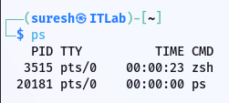

## **1.45. Command Name:** top

**Syntax**: top [options]

**Usage**: Displays real-time system processes and resource usage.

### **Commands Executed:**

- $ top — Opens an interactive view of running processes.

**Output**:

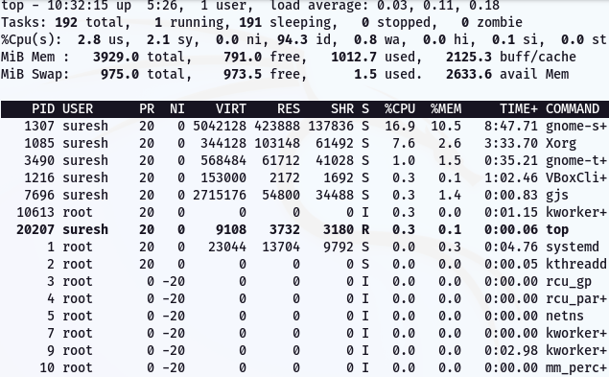

## 1.46. Command Name: kill

**Syntax**: kill [options] [PID]…

**Usage**: Terminates a process by PID.

### **Commands Executed:**

- $ kill 11 — Terminates the process with PID 11.

**Output**:



## **1.47. Command Name:** pkill

**Syntax**: pkill [options] <pattern>

**Usage**: Terminates processes by name.

### **Commands Executed:**

- $ pkill firefox — Kills all processes with the name 'firefox'.

**Output**:



## **1.48. Command Name:** killall

**Syntax**: killall [OPTION]... NAME...

**Usage**: Kills all instances of a process.

### **Commands Executed:**

- $ killall chrome — Kills all instances of the chrome process.

**Output**:



## **1.49. Command Name:** bg

**Syntax**: bg [options]

**Usage**: Resumes a background process.

### **Commands Executed:**

- $ bg %1 — Resumes the first background job.

**Output**:

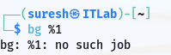

## **1.50. Command Name:** fg

**Syntax**: fg [options]

**Usage**: Brings a background process to the foreground.

### **Commands Executed:**

- $ fg %1 — Brings the first background job to the foreground.

**Output**:

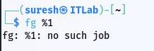

## **1.51. Command Name:** tar

**Syntax**: tar [OPTION...] [FILE]...

**Usage**: Archives files.

### **Commands Executed:**

- $ tar -cvf archive.tar file.txt — Archives file.txt into archive.tar.

**Output**:

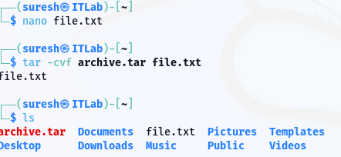

## **1.52.** **Command Name**: gzip

**Syntax**: gzip [OPTION]... [FILE]...

**Usage**: Compresses files using the gzip algorithm.

### **Commands Executed:**

- $ gzip file.txt — Compresses file.txt into file.txt.gz.

**Output**:

